|  |  |  |
| --- | --- | --- |
|  | **BAHRIA UNIVERSITY, (Karachi Campus)**  *Department of Software Engineering*  **Assignment 3 - Spring 2023** |  |



COURSE TITLE: **Engineering Management** COURSE CODE: **MGT-423**

Class: **BSE-IV (B)** Shift: **Morning**

Course Instructor: **Engr. Rizwan Fazal** Time Allowed:  **12/06/2023**

Submission Date: **19/06/2023** Max. Marks:05

Name: **Muhammad Shoaib Akhter Qadri** Enrollment No: **02-131212-009**

**[CLO4: 5 Marks]**

**QUESTION #01**

Evaluate the R&D process that is required to develop a better product?

**SOLUTION**:

**Research and development** are commonly lumped together under the catchall term “R&D.” To distinguish between them, let us adopt the definitions commonly used by the National Science Foundation:

**Research**, both basic and applied, is systematic, intensive study directed toward fuller scientific knowledge of the subject studied.

**Basic research** is . . . research devoted to achieving a fuller knowledge or understanding, rather than a practical application, of the subject under study . . . [although when funded by commercial firms, it] may be in fields of present or potential interest to the company.

**Applied research** is directed toward the practical application of knowledge, which for industry means the discovery of new scientific knowledge that has specific commercial objectives with respect to either products or processes.

**Development** is the systematic use of scientific knowledge directed toward the production of useful materials, devices, systems, or methods, including design and development of prototypes and processes.

Now I you can get more information about ideas, technology and R&D etc, in which are following:

● Sixty ideas (from researchers, other employees, customers, and suppliers) need to be screened quickly down to.

● Twelve ideas worthy of preliminary technical evaluation and analysis of profitability, to produce.

● Six defined potential products worth further development, for obtain

● Three prototypes for detailed physical and market testing, resulting in.

● Two products committed to full-scale production and marketing, of which .

● One product should be a real market success.

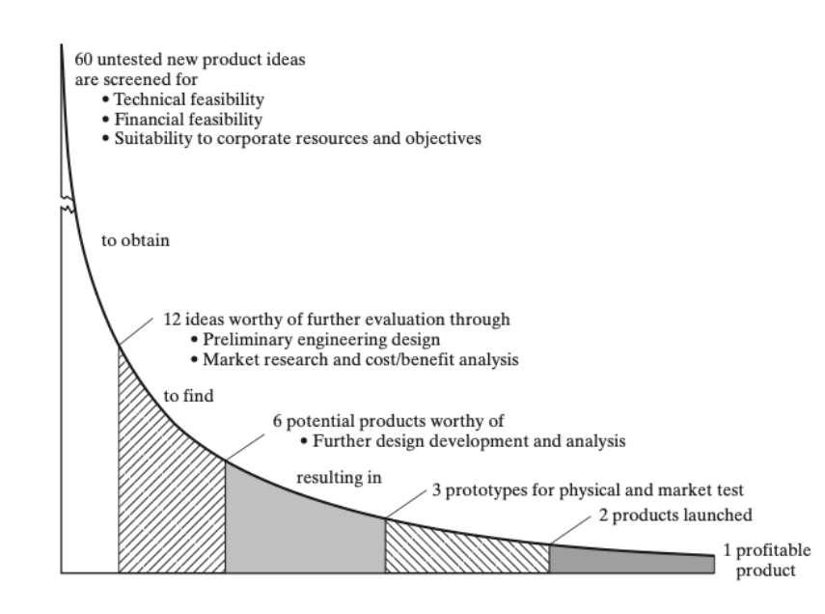

Research and development projects are set up to achieve a range of objectives and business needs. These could be around introducing a new product or service, improving an existing process or utilising a new technology.

To slash 60 crude ideas into 12 worthy of any significant evaluation requires a method that is quick and inexpensive. A common method is use of a simple checklist, in which the proposed product is given a simple judgmental rating (poor/fair/good/excellent or -2> -1> +1> +2, for example) for each of a number of characteristics. Seiler suggests, for example, scoring 10 items:

**1.** Technical factors (availability of needed skills and facilities; probability of technical success)

**2.** Research direction and balance (compatibility with research goals and desired research balance)

**3.** Timing (of R&D and market development relative to the competition)

**4.** Stability (of the potential market to economic changes and difficulty of substitution)

**5.** Position factor (relative to other product lines and raw materials)

**6.** Market growth factors for the product

**7.** Marketability and compatibility with current marketing goals, distribution methods, and customer makeup

**8.** Producibility with current production facilities and manpower

**9.** Financial factors (expected investment need and rate of return from it)

**10.** Patentability and the need for continuing defensive research

Often these R&D projects will have unknowns and uncertainties at their core – and the R&D is aiming to resolve these. It is this uncertainty that forms a core aspect to the definition of R&D for tax purposes. An example of an R&D project could be to migrate a legacy system onto the cloud, automate an aspect of the manufacturing process, or utilise new materials to improve performance.

Businesses will approach R&D in different ways, with different organisational structures implementing different R&D strategies. How R&D is leveraged internally also varies dramatically between businesses, having a significant bearing in terms of its overall impact.

Some businesses won’t have the capability to do R&D in house so will outsource their R&D, relying on others to drive innovation. Some businesses choose to outsource their R&D while others have R&D departments entirely dedicated to R&D. R&D is a complex function within any business and often comes with its challenges. Many R&D leaders struggle to reduce development times as well as plan and roadmap more effectively for the future. Building a culture of innovation across a business through R&D is often a goal for many businesses but one that is also hard to achieve.

It’s not enough to simply carry out R&D. In order to make the most out of an R&D function, you need to strategies. Regardless of your R&D objectives, whether you want a competitive edge, a first mover advantage to capitalise on a new technology, to keep up with a competitor or break into a new market – how you plan and strategies around R&D is essential.

An R&D program that is strategic will reap benefits. When combined with R&D tax credits, it becomes even more advantageous. You may want to adapt your R&D processes and planning to make more use of R&D tax credits. The ultimate goal is for R&D to permeate a company’s culture and approach to business. The uncertainty at the heart of the potentially most lucrative R&D projects can be mitigated financially by the use of R&D tax credits. You can get rewarded for taking more risks. This helps effect a change in mindset when approaching risky projects. This is where our sector experts and chartered tax advisers come in. At Forrest Brown, we work closely with businesses to help them make the most of their R&D. Research and development is closely linked to innovation. Innovation is a broad term and can be difficult to define. It often refers to those ideas, products, services, and methods/processes that are new and different. R&D activity and projects is one of the main ways a business will seek to innovate. When it comes to R&D activity, innovation can mean new to your business or genuinely unique. Innovate summarize this: “‘new to me’ innovation encompasses proven technology being applied in new and creative ways. Whilst the technology itself might not be brand spanking new, the application or product is novel.”

Although not all R&D leads to innovation, it’s unlikely that innovation occurs without some degree of R&D.

The definition of innovation for R&D for tax purposes is narrower. This means that R&D tax credits can’t be a substitute for innovation. R&D for tax purposes focuses specifically on achieving an advance in science or technology and resolving uncertainty.

As we’ve discussed, R&D is important to business growth and your ability to compete in a market. A business that can innovate and adopt new technologies as well as improving existing processes is more likely to succeed in the long run.

At a wider level, the benefits of R&D extend into entire sectors as well as positively impacting the wider economy. A sector that invests heavily in R&D will develop and achieve more, including providing real-world benefits to people.

For many countries, R&D and economic growth go hand-in-hand. Some form of R&D incentive often feature as part of a government’s plans to grow its economy. This is because they are designed to improve productivity. The new UK Government has made R&D tax credits a cornerstone of policy. Research and development is closely linked to innovation. Innovation is a broad term and can be difficult to define. It often refers to those ideas, products, services, and methods/processes that are new and different. R&D activity and projects is one of the main ways a business will seek to innovate. When it comes to R&D activity, innovation can mean new to your business or genuinely unique. InnovateUK summarise this: “‘new to me’ innovation encompasses proven technology being applied in new and creative ways. Whilst the technology itself might not be brand spanking new, the application or product is novel.”

Although not all R&D leads to innovation, it’s unlikely that innovation occurs without some degree of R&D.